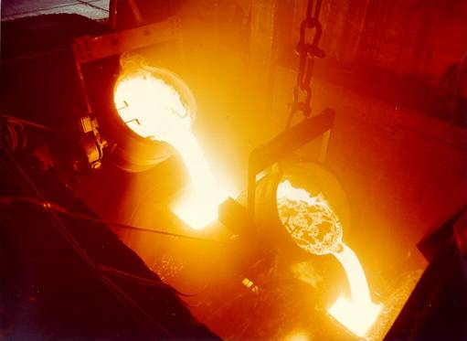

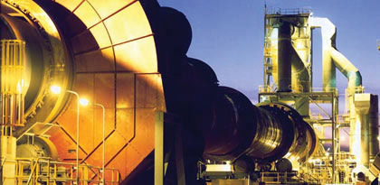
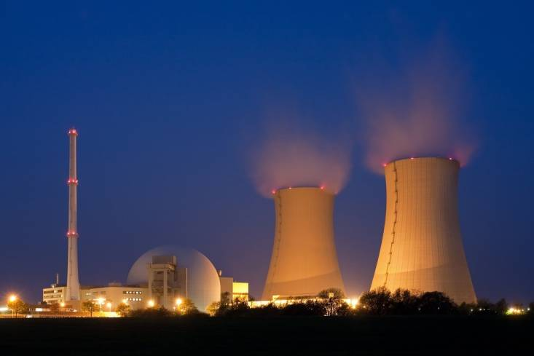
Tensor Systems Predictive Maintenance

The World’s Most Sophisticated Predictive Maintenance Monitor
Finding faults in the early stages allows for planned repairs, eliminating unplanned shutdowns and expensive catastrophes
TS-2 Online Condition Monitoring System

Features:
- Measure vibration, speed, load, metallic particles and water in oil
- Regular (hourly) monitoring of growing faults
- Recognize and trend individual faults
- Alarms sent via text message and/or E-mail
- Intuitive software
- Complete information (Alarms, Trends, Spectra, Cepstrum, Kurtosis, etc.)
- Applicable to slow and variable speed machines
- Remote monitoring, analysis and support worldwide
Automated fault detection:
- shaft related faults (imbalance, misalignment, looseness, bent shaft, etc.)
- bearing faults (determining stage of failure)
- gear faults (determining stage of failure)
- single tooth faults detection for every tooth in a gearbox
- installation faults
- oil contamination (wear debris and water)
- electrical faults

Life Remaining:
- each fault is trended over time
- increase in fault severity is used to determine remaining life of component

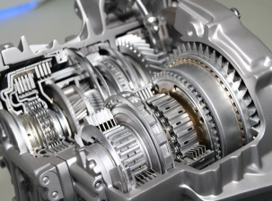
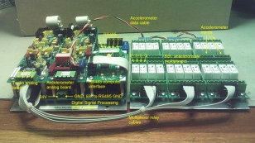
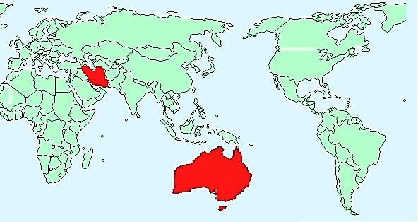

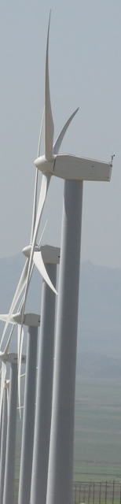
Remote analysis and support

Tensor System’s specialists analyze and trend your equipment condition.

- Rapid response to fast changing machine conditions
- 24/7 consulting and practical condition monitoring advice from qualified and experienced engineers
- Monthly report outlining machine condition and required planned repairs

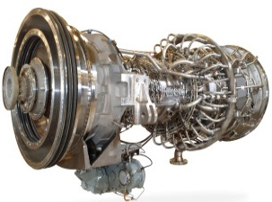
Client Site PCs
TS-2 hardware
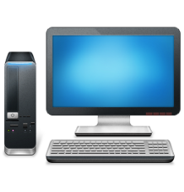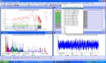


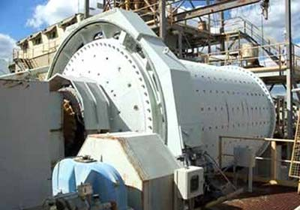
Sensors
and
Cables

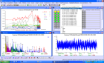
Online oil analysis is used to detect Ferrous and Non Ferrous particles. Oil moisture content is measured such that remedial action can be taken prior to water content rising to destructive levels.
TS-2 software trends overall vibration, synchronous vibration, non-synchronous vibration, spectra, cepstrum, kurtosis, etc. for a complete analysis. When a trend starts increasing in amplitude, the rate of increase is used to determine the length of time before an alarm level is reached. This is indicative of time to failure.
TS-2 database retains data for the optimum combination of trouble-shooting a recently developed problem and maintaining historical data for trending purposes.
Authorized Dealer:
Spectrum Technologies Ltd.
920 Concession 8 West, RR 3,
Puslinch ON N0B 2J0
905-659-6478 (F) 905-659-6479
www.spectrum-tec.com
info@spectrum-tec.com
10 Pigeon Bank Lank
Warrandyte Vic 3113
Australia
www.tensorsystems.com
Why TS-2?
In comparison with other monitoring systems, there are important benefits in the TS-2 monitoring system.
- A complete turnkey system including:
  - hardware
  - software
  - custom database with alarms
- Monthly review of each machine by vibration expert
- Wide range of application:
  - High & low speed machines
  - mining mills, steel rolling mills, wind turbines etc.
- Range of sensors used:
  - tachometers
  - motor load
  - accelerometers, velocity sensors, proximity probes
  - acoustic emission sensors
  - temperature sensors
- 24 bit accuracy to 32 KHz.
- Traffic Light display of machine condition provides intuitive user interface and a simple way to show if there is a problem
- Problems reported immediately via SMS and email
Experienced Vibration Analyst
Technology Used
The critical part of an Online Condition Monitoring System is automated fault identification. This requires systematic data processing leading to reliable fault determination and trending.
TS-2 uses tachometers and gear ratios to accurately and continuously determine all shaft rotational speeds. This is equally effective on high and low speed machines during steady speed or variable speed operation. The shaft speed is used to separate the vibration into synchronous and non-synchronous components.
Anti-friction bearing vibration is non-synchronous while shafts and gears produce synchronous vibration. Single tooth faults produce low amplitude harmonics of shaft speed and sidebands of the meshing frequency. NASA developed algorithms (NA4, FM4, SI and Phase Demodulation) are used to trend fault progression.
Electrical faults are determined from vibration harmonics, sidebands and slip frequencies.

